**Microscoft PowerPoint Enhancement using LLM’s**

**Project Objective:**  
To develop an AI application that can enhance PPT based on user feedback, it may be content, formatting or visual design changes.

**Process:**1. PPT as Input

2. Extract User Feedback from the PPT – may be within the slides, Notes sections, comments, Hand drawn images/tables.

3. Check if the changes apply to a single slide or the entire presentation.

4. Use LLM to Classify the Feedback – text changes, theme or background changes, formatting & layout adjustments, visual enhancement.

5. based on the classify feedback implement them using LLM models

**Research:**

**PowerPoint Object Model**

It defines a hierarchical framework for programmatically accessing and manipulating PowerPoint elements like slides, textboxes, images, tables, and charts, enabling automated tasks through languages such as Python, VBA, and the Microsoft Graph API.

1. PowerPoint Application Object – It represents the PowerPoint environment. It serves as the entry point for automation, enabling tasks like opening files, creating new presentations, and accessing global settings.
2. Slide Object - Each slide contains various elements like textboxes, images, and tables.
3. Shape Object – It has textboxes, charts, SmartArt, and other graphical elements.
4. TextRange Objects – It allows manipulation of text properties like font, color, alignment
5. Table and Chart Objects - Represent structured data and visual elements.
6. Slide Master & Layouts - Control the default design and structure of slides. Control global styling, including fonts, colors, and background settings.
7. Theme & Formatting Rules: Define how design elements like fonts, spacing, and colors are applied.

**Direct Object Manipulation in PowerPoint**

PowerPoint allows direct object manipulation through:

1. COM (Component Object Model) Automation - It uses the Win32 API (win32com.client) for direct manipulation of PowerPoint objects and UI automation. While it provides detailed control over PowerPoint's functionality, it is Windows-only. This approach is best for server-side automation in a Windows environment but may not be best for a cross-platform or cloud-based solution.
2. python-pptx Library – best for generating and modifying presentations offline. It allows the backend to modify slide contents, change backgrounds, edit text, and apply simple formatting. For tasks like background color change, basic visual updates, and simple content edits from notes, this library is best. It does not support advanced visual enhancements or real-time UI changes.
3. Microsoft Graph API – It enables interaction with cloud-stored PowerPoint presentations like storing in OneDrive or SharePoint. It can access and modify PPTX files in the cloud, but doesn't provide the direct UI manipulation.
4. VBA (Visual Basic for Applications) - A built in scripting environment within PowerPoint for automating tasks, manipulating objects, and interacting with the PowerPoint UI. It is not sutabile for backend process where automation is needed.
5. XML – It deals with the internal file structure of PowerPoint presentations. It works with the Open XML format used by PowerPoint. For advanced visuals manipulation this is not good.
6. Office.js – It enables developers to create web-based add-ins that can extend the functionality of PowerPoint. it can access cloud-based services and store files in OneDrive or SharePoint. It allows manipulation of cloud-stored presentations and real-time edits. For tasks like theme improvement, advanced layout changes, or complex visual updates this is best.

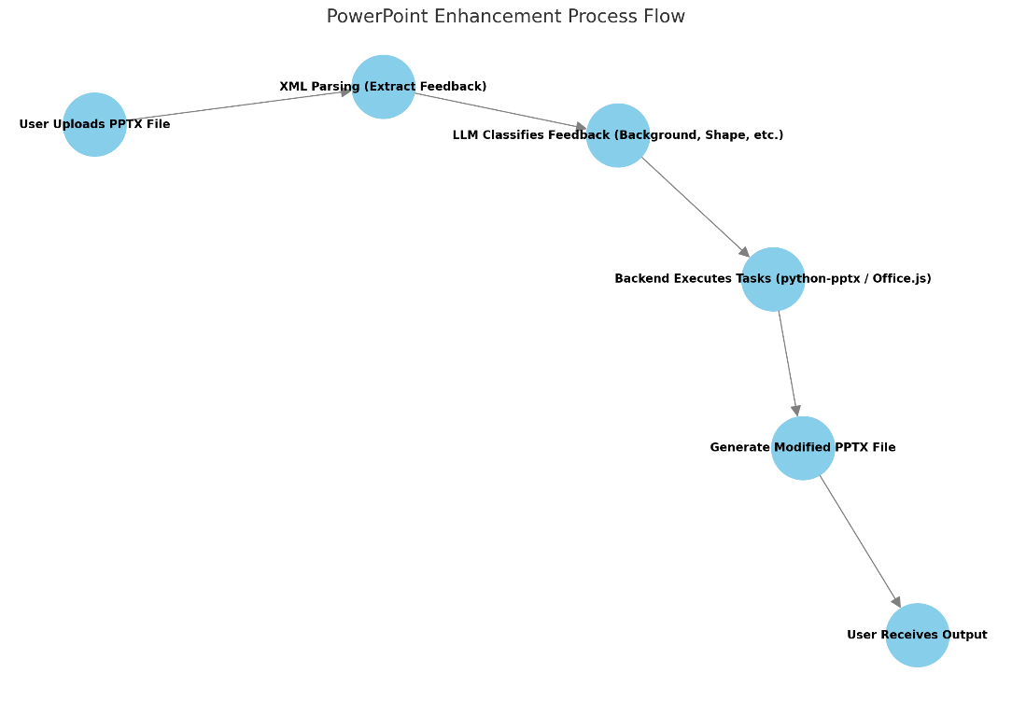

If we want to modify PowerPoint directly in it then Office.js is best if not then python PPTX is best

Office.js is best for real time modifications in the PowerPoint itself. It requires to open the required PPTX file. It uses Add-ins platform to interact and we can do these

* Manually load the add-in in PowerPoint – locally in system
* Microsoft AppSource – for public
* Microsoft 365 Admin center – for an organization

We can perform tasks like Slide & Text Manipulation, Connection with API’s and also it can insert text, change formatting, and add tables/shapes.